Creative Brief
SILVER

Client: | Kärcher
Date: | 01.05.18
Job Title: | Kärcher - Preventative cleaning content synopsis
Synergist Job & Phase Number: | 2242.004
Account Manager: | Natasha
Budget: | TBC
Date Required: | 03.05.18
Author: | Natasha

Outline of the project
What are the details of the project - set the scene clearly and cover off the top level aim of the brief.

With more budget available, for our second content piece for Kärcher we’d like to expand our topic for theme 2 from a tip sheet to a short e-book (or similar).

Sticking with the same idea of preventative cleaning, we think that this topic has legs to become something more than just a tip sheet. We would like the piece to talk about the differences between preventative, reactive and routine (cleaning and general business), and why each is relevant but preventative can help save you money.

We’d still like it to include a section on preventative cleaning tips but have this as one of the sections.

As we now have more budget we think this could be developed into a short e-book where we cover off other area’s related to value & cost reduction such as:
- Outsourcing vs in-house cleaners
- Clean to cut costs/how much is cleanliness costing you

Cost, value and efficiency is all particularly important to the industries we are targeting, so focusing on points that would matter to our audience is important. Our industries are:
- Auto industry (manufacturer)
- Transport
- Mechanical Engineering (manufacturer)
- Food industry (manufacturer)

From the plan that was initially put together, the synopsis we wrote is below. We’d like to update the synopsis with the above information for client approval before briefing in the full piece.

Theme 2: value/cost reduction/preventative cleaning
Tips for preventative cleaning
Taking the form of a tip sheet or checklist, this piece of content will be a usable tool which will help Kärcher customers implement a preventative cleaning programme. Showing an understanding of the decision-makers’ pain points, this will position Kärcher as a company prospects can trust.

Tip 1: Wetting floors or using sweeping compounds before sweeping reduces the amount of airborne dust
Tip 2: Trapping chips, shavings and dust before they reach the floor can prevent their accumulation
Tip 3: The best way to control spills is to stop them before they happen - use drip pans and guards where possible spills might occur

At Kärcher, we know cleaning. Whether it’s preventative, routine, or reactive, we have the knowledge and expertise to help you minimise cleaning time, costs, and resources.

Problem to solve
Outline the main problems the client is trying to overcome, including why and how we need to engage, and any perceptions we need to change.

For the campaign the main perceptions we need to overcome are:
- That Kärcher is a pressure washer company only, when in fact they have a full selection of cleaning equipment, solutions and services that will suit
- That Kärcher only do consumer products

This particular content piece should demonstrate that Kärcher knows the best methods of cleaning to ultimately save that business money in the long run. We should focus on the cost reductions an effective cleaning solution can have on businesses. It should be interesting and engaging to the audience so they see Kärcher as an expert in their industry.

Target audience
Who are we talking to? What are their needs and wants? Reference detailed personas here.

Our audience includes:

Industries:
Automotive industry
Food industry
Mechanical Engineering industry
Transport

Job titles:
SDM’s (Managing Director)
Finance/Buyers (Finance Director, Procurement Manager)
Facilities (Office Manager, Health & Safety Manager, Fleet Manager etc.)

Objectives
What behaviour do we need to activate. What is the ultimate objective - our call to action?

Our ultimate aim is to generate leads and book appointments on behalf of the sales managers, but the objective for content/HTML is to change perceptions from a consumer-focused brand that mainly produces pressure washers, to a professional one that deals with all levels of cleaning equipment. We also want to nurture this audience through education and positioning Kärcher as leaders/experts in the field.

Content objectives:
- To build awareness & drive engagement
- To be seen as thought provoking, innovative and experts within these industries
- Produce content that is relevant and interesting to the audience
- Nurture prospects so we build an affinity with them, ultimately encouraging appointments
- Progress prospects through the purchase funnel

Key messages
What are the key messages we need to express. Is there a single minded proposition. What is the big idea that we need to align to?

Kärcher is the worldwide leader in cleaning technology. Whatever you need to clean – Kärcher has the solution. Kärcher has the knowledge, experience and equipment to help you combat any cleaning challenge. From routine, to reactive, and most importantly preventative we have the tools to save you time and money.

Tone of voice
How should we speak and engage with our audience. In an authoritative, friendly manner?

Powerful - We are proud of our products. We like to show them – best of all with a smile.
Refreshing - We always present our motives with an element of surprise, exciting and slightly exaggerated.
Straightforward - We are real, accessible and straightforward and always put people, products and services first.

See Brand Language Guidelines.

Existing assets
What elements already exist? Do we have a copy platform? Does imagery exist we can use? Do we have a logo, brand toolkit at our fingertips? Are there any creative examples existing already we can reference?

Brand Guidelines & Style Guidelines are saved in my transfer folder for review, along with industry focused brochures and examples of previous work.

Project mandatories
What do we need to do to stay on brand, on budget and on time?

Brand Guidelines and Brand Language Guidelines.

Technical information
What specific information do we need to know to enable us to deliver best practice creative? Dimension of the piece, print or digital specifications, file formats required, etc

Short e-book, including tips, facts and information about the benefits and cost reductions cleaning can bring.

Other considerations
Is there any other relevant information that will help us create the best outcome possible?

View Messaging Hierarchy – this details pain points and drivers for these job titles in these specific industries.

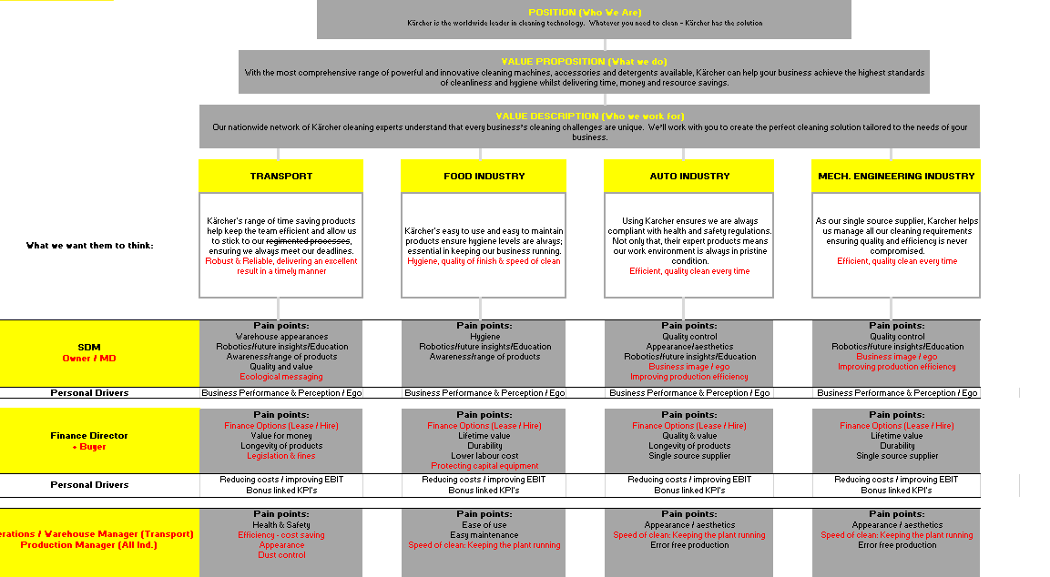

Deliverables
What style, tone or experience will have the most relevance and impact across our creative deliverables?

- Easy to digest/snackable information/visual
- Interesting
- Help position Kärcher as experts

Sign Off
Who needs to approve the project before it goes to client? When does it need to be delivered?

Kenny, Clare, Natasha

